Data Audit Report
Employee attrition dataset · CortexHR AI/ML · Task 1
Written for the AI/ML team · 15 October 2026 · Data: the attrition_dataset sheet
Code, notebook and decision log: https://github.com/dikshit0012/context-hr
The short version
The data is usable, but not straight out of the box. Before a model sees it we need to remove 6 duplicate rows, fix a few numbers that can’t be true, correct 3 salaries that have an extra zero, and drop 6 columns that quietly contain the answer. If we skip that last step, a model will look amazing in testing and be useless in real life.
Every problem in this report has a decision next to it. Two of them aren’t ours to make, because only the Python team knows the answer. We’ve listed those as open questions in section 7 instead of guessing.

2,389 × 42  rows × columns | 14.6%  left within 12 months | 6  duplicate rows | 6  columns that leak the answer | 3  salaries with an extra zero
Each row is one employee on one date, with the answer we want to predict: did they leave within 12 months? 383 rows are real employees measured on 30 September 2025, 2,000 are simulated history (2021–2025) and 6 are accidental copies. Column dictionary: docs/data_dictionary.md.

1. Blanks in the data
Eleven columns have blanks. We expected data-entry gaps, but most of them aren’t. Usually a blank just means the question doesn’t apply to that person.
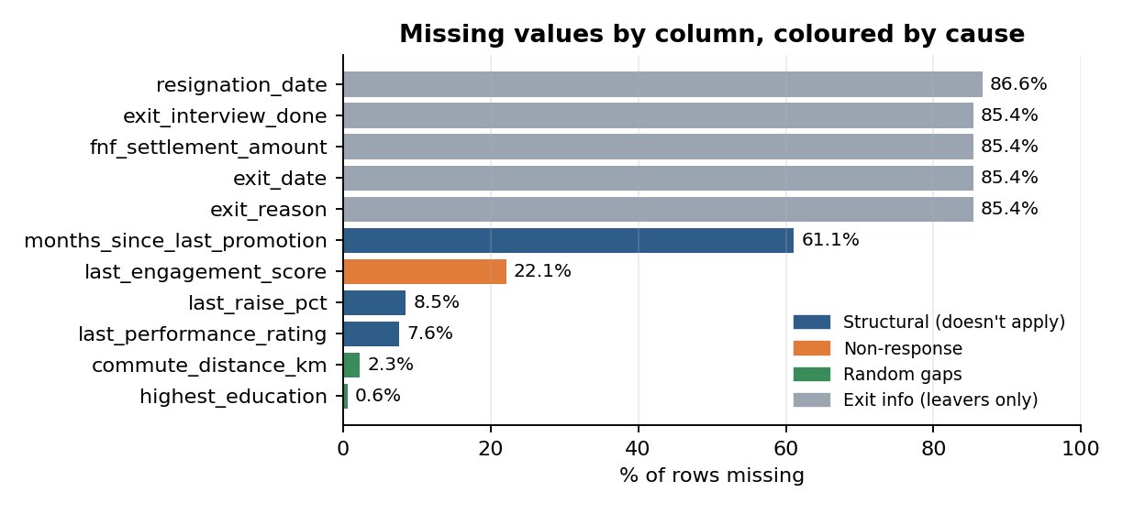
Figure 1. Share of blank cells in each column, coloured by why they’re blank.
- A blank often means “none”. People who’ve never been promoted (61.1%) have no promotion date, people who’ve never had a raise (8.5%) have no raise size, and people who joined under a year ago (7.6%) haven’t had an appraisal yet.
- 22.1% didn’t answer the engagement survey. They leave a bit more often than people who did (16.7% vs 14.0%), but the gap is small enough to be chance (p = 0.148).
- Only commute distance (55 rows) and education (15 rows) look like genuine random gaps.
- The five exit columns are blank for everyone who stayed. That isn’t missing data, it’s a leak. Section 5 covers it.
What we’ll do: keep these columns, fill each blank with a sensible neutral value, and add a “was missing” flag where the blank means something. Fill values are worked out from training data only.
If a column were 40% missing, what would we do?
Ask why before deciding anything. If the blank means something, like “never promoted”, we keep the column, fill the gap and add a “was missing” flag. Filling on its own would pretend the value was real, and dropping the column would throw away a useful signal.
We’d only drop a column if it’s mostly empty, the blanks mean nothing, and it adds no information (or if it leaks the answer). Our own example is months_since_last_promotion: 61.1% blank, well over 40%, and we’re keeping it.

2. Numbers that can’t be right
Some values aren’t just unusual, they’re impossible. We wrote simple rules from the data dictionary and counted how often each one is broken.
Problem | Rows | What we’ll do
Exact duplicate rows (same employee twice) | 6 | Drop the second copy, and keep each person on one side when we split data for training and testing
Negative tenure (observed before they joined) | 4 | On hold (question 1). We haven’t changed the numbers; we’re waiting for the real join dates
Attendance above 100% (1.12) | 2 | Cap at 100%
Same city spelled differently (Bangalore / Bengaluru, Madras / Chennai, Delhi-NCR …) | 13 | Use one spelling for each (16 labels become 9 cities)
Work-from-home share below 0% or above 100% | 213 | Clip to 0–100%; it’s tiny noise
Total experience smaller than time at this company (simulated rows only, like the WFH issue) | 137 | Raise it to match tenure

3. Unusual values
We tried two standard tests. The IQR test flags anything far outside the middle half of employees. The z-score test flags anything more than 3 standard deviations from the average. IQR flagged 1.6 to 7 times more rows (salary 93 vs 26, daily hours 48 vs 15, tenure 73 vs 45). Pay, tenure and overtime have a few very large values that drag the average up, so z-score lets more through. Neither test can tell a typo from a genuinely big number, so for salary we added a check: pay divided by comp ratio should match the role’s mid-point.
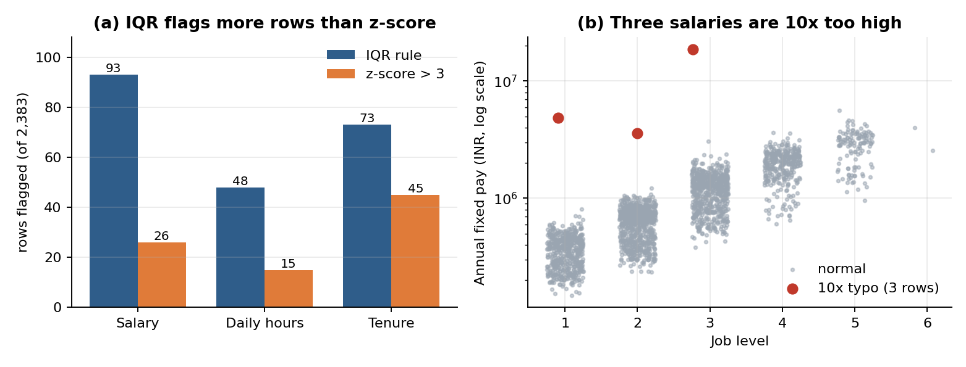
Figure 2. (a) Rows flagged by each test. (b) The mid-point check singles out exactly three salaries that are 10 times too high.
- Salary: that check found three salaries about 10 times too high (EMP-0034, EMP-0433 and EMP-0601). Dividing each by 10 puts it right where its job level belongs, so it’s an extra zero. The other big salaries belong to real senior people.
- Hours: EMP-0313 averages 1.8 hours a day with 20% attendance. The two numbers agree with each other, so it looks like a real long absence, not a typo.
- Tenure and overtime: tenure of up to 13.7 years is real, and only the 4 negative values are wrong. 81% of people do no overtime at all, so IQR flags anyone who does any (445 rows). That’s normal.
What we’ll do: correct the 3 typos (divide by 10), keep the genuine extremes, ask HR about EMP-0313, and use log scales for pay and overtime in linear models.

4. How many people leave
349 of 2,383 people left within 12 months, which is 14.6%. The other 85.4% stayed, so there are about six stayers for every leaver. A lazy model that always says “nobody leaves” would be right 85.4% of the time and find no one, so plain accuracy is a poor score here. The rate is steady from year to year (13.5% to 16.3%). Customer Support loses the most people (21.1%) and Legal the fewest (6.5%), though Legal has only 62 rows.
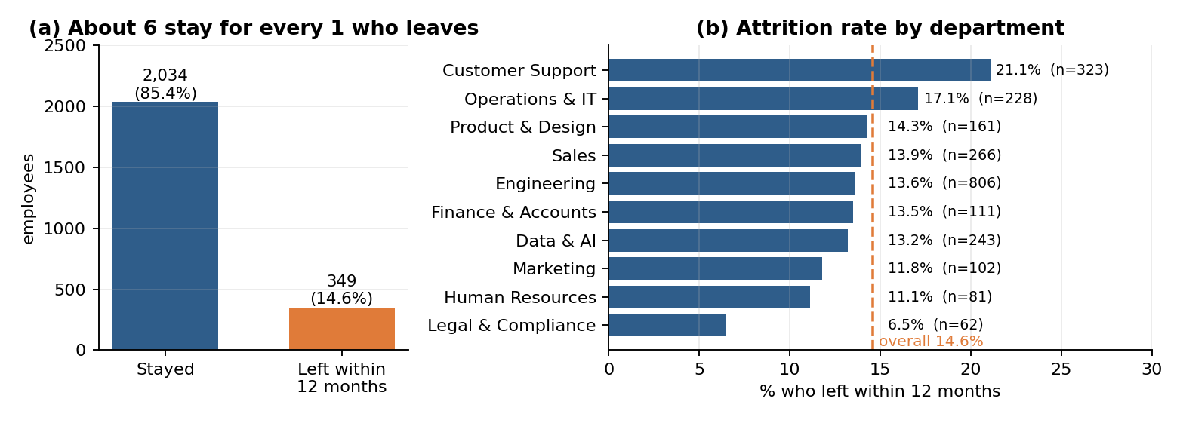
Figure 3. (a) Stayed vs left. (b) Attrition rate by department.
What we’ll do: leave the data as it is, split it so every fold keeps about 14.6% leavers, and judge models by ROC-AUC, PR-AUC, precision and recall rather than accuracy. Start with class weights.

5. Columns that give away the answer
Data leakage means the model gets to see information during training that won’t exist when it has to make a real prediction. Our prediction moment is 30 September 2025, so anything created after that date, or worked out from the answer, is cheating.
 | 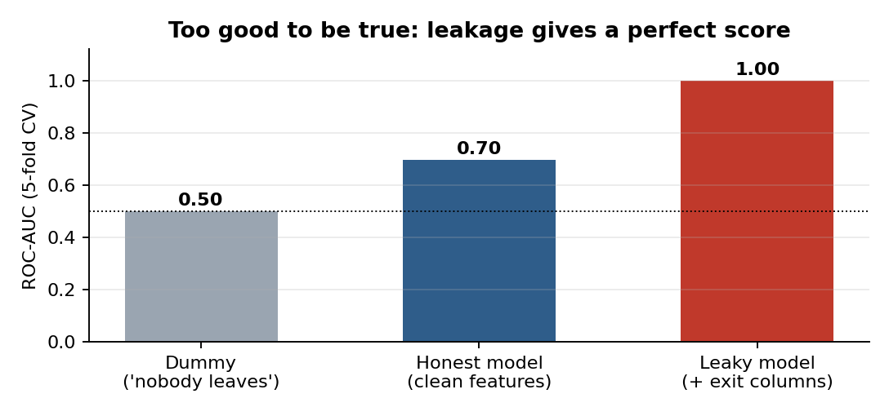  Figure 4. The same model with and without the exit columns.
  Leaking column | Why it leaks
  exit_date | Exists only for leavers
  exit_reason | Recorded at the exit
  exit_interview_done | Held at the exit
  fnf_settlement_amount | Paid at the exit
  resignation_date | Exists only for resigners
  voluntary_left_within_12m | A sub-label of the answer itself
To prove it, we trained the same simple model twice. With ordinary columns it scores 0.70 (ROC-AUC, where 0.5 is a coin flip). Add the exit columns and it scores 1.00. A near-perfect score should make us suspicious, not happy.
- Three other sheets run past 30 September 2025: 21% of survey rows, 21% of appraisals and 68% of attendance months. When we build features from them we have to stop at the observation date.
- Some columns aren’t leaks but still shouldn’t be features: row_id, employee_id, source and observation_date. Gender and age sit in a separate sheet and stay out of the model; we’d use them only to check for fairness. We also haven’t confirmed that dept_attrition_rate_prior_12m is safe (question 2).
What we’ll do: drop the six leaking columns before any modelling, and add a check that fails loudly if one ever reaches the feature table.

6. Decision list for Task 2 (full log: docs/decisions.md)
ID | Issue | What we’ll do
D01 | Duplicate rows (6) | Drop the second copy; split by employee_id
D02, D04–D06 | Spelling, attendance over 100%, WFH share, experience below tenure | One spelling per city; cap attendance at 100%; clip shares to 0–100%; raise experience to match tenure
D03, D24 | On hold: negative tenure; dept_attrition_rate_prior_12m | Open questions 1 and 2. Nothing assumed; section 7 says what we do meanwhile
D07–D10 | Salary typos; genuine outliers; EMP-0313; overtime | Divide 3 typos by 10; keep real extremes; flag EMP-0313; log-transform pay and overtime
D11–D16 | Blanks: never happened, no survey answer, random gaps | Keep; fill (tenure, 0, median, “Unknown”); add a “was missing” flag
D17, D23 | Imbalance (14.6% leave); fill and scaling rules | Stratified splits, class weights, ROC-AUC, PR-AUC, recall; learn fill and scaling rules from training data only
D18–D22 | Exit columns; post-snapshot rows; identifiers; protected attributes | Drop exit columns and assert they never reach the model; stop at observation_date; keep IDs, source, gender and age out of the features

7. Two questions for the Python team
Only the people who built the data can answer these, so we haven’t guessed. Answers go in the last column and in docs/open_items.md.
ID | Question and why it matters | What we’re doing meanwhile | Their answer
1 | What are the real joining dates for EMP-0248, EMP-0280, EMP-0568 and EMP-0596? Their tenure comes out as −4, −5, −2 and −1 months, which can’t be right, and nothing else in the workbook tells us the true dates. | We’ve left the numbers as they are and flagged them. These 4 rows (0.2% of the data) stay out of training until we hear back. | Pending
2 | Is dept_attrition_rate_prior_12m worked out only from people who left before each row’s observation date? If it includes later exits, it quietly leaks the answer. What we’ve seen fits: for real employees it sits 0.7 points from the prior 12 months of exits in the headcount sheet, versus 10.8 points from the following 12 months. That’s a good sign, not proof, and we haven’t tested the simulated rows. | Treated as a maybe: models are trained and reported with and without it until we know. | Pending
3 | (Extra, less urgent) Why do only the simulated rows show total experience below time at the company (137 rows)? | We raise experience to match tenure (rule D06) and will revisit if there’s an explanation. | Pending
Cross-check: ydata-profiling agreed with our blank and duplicate counts but missed the impossible values, typos and imbalance. All 98 of 98 planted problems in the workbook’s answer key are covered, but the key was visible while we explored, so this is a completeness check, not a blind test.

8. Repository and how to reproduce this audit
Everything behind this report (notebook, scripts, figures, tables, decision log and open questions) lives in one public repository: https://github.com/dikshit0012/context-hr. Anyone on the team can re-run the audit and get the same numbers.
Where | What's there
notebooks/01_data_audit.ipynb | The completed audit, with every output, for exploring each finding
scripts/run_audit.py | Runs the whole audit from the command line, no notebook needed
src/cortexhr/ | Reusable audit helpers that Task 2 will build on
tests/ | Unit tests for the helper functions
reports/ | This report (.docx and .pdf), figures/, tables/, findings.json and the ydata-profiling output
docs/ | data_dictionary.md, decisions.md (D01–D24) and open_items.md (the answers to section 7 go here)
data/ | raw/ holds the original workbook; interim/ and processed/ are for Task 2 outputs
Three working rules shape the repo. The original workbook stays read-only. Cleaning never overwrites it; Task 2 writes to separate interim and processed folders. Decisions are written down in docs/ apart from the code that applies them. And the audit is reproducible from a single command.
How to run it. Docker is the recommended route. Copy 02_CortexHR_AI_ML_Dataset.xlsx into data/raw/ (it is not committed to GitHub), then run these from the project root:
docker compose run --rm audit # run the full audit, write figures, tables and findings.json
docker compose up jupyter # explore the notebook at http://localhost:8888
docker compose run --rm test # run the unit tests
Without Docker: create a virtual environment, run pip install -r requirements.txt, set PYTHONPATH to src, then run python scripts/run_audit.py.
Data privacy. The workbook contains employee records, so it must stay out of version control (check .gitignore before every push). This report names a few employee IDs (EMP-0034, EMP-0313 and others), and the repository is public, so review reports/ for identifying details before sharing outside the team.
Where this goes next (Task 2). Turn the decisions in section 6 into a reusable, tested pipeline: (1) get answers to the open questions in section 7; (2) apply the approved cleaning rules and drop the six leaking columns, with a check that fails loudly if one reaches the features; (3) fill blanks by meaning and add the “was missing” flags; (4) keep the target separate from the features and stop time-based features at 30 September 2025; (5) write interim and processed datasets and test that every documented rule is applied. Current status: findings documented, two questions still open.

